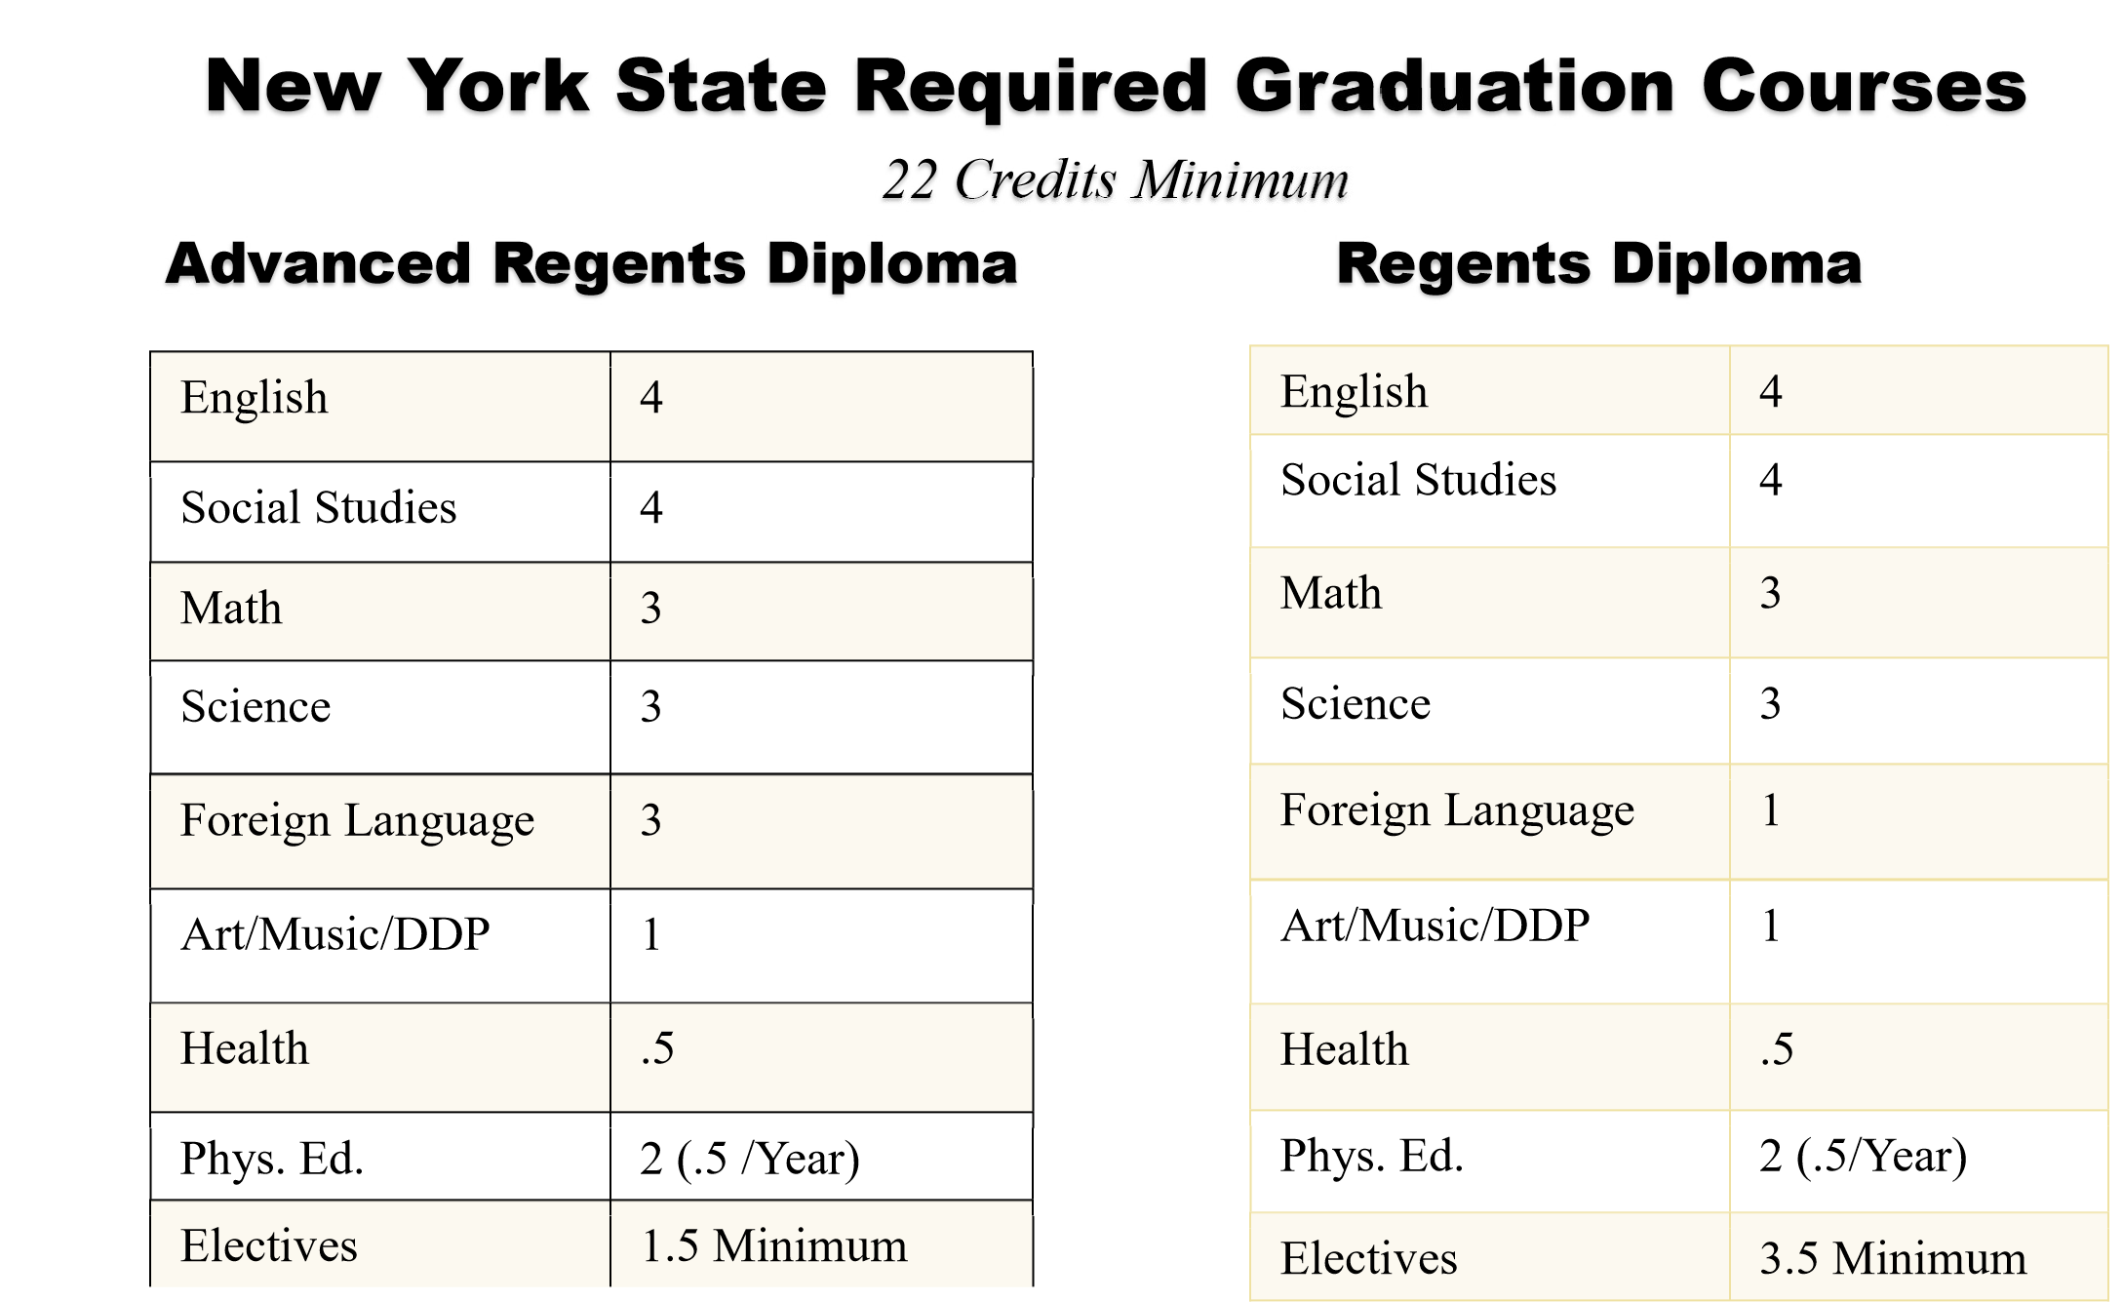
Graduation NYS Regents Exam Requirements
Subject | Advanced Regents Diploma | Regents Diploma
Math | Algebra I and  Geometry and  Algebra 2CC  *Must pass all 3 with 65 and above | Algebra I  *Must pass one with 65 and above
Science | Two (2) Science:  - One (1) Physical Setting  - One (1) Life Science  *Must pass both with 65 and above | One (1) Science:  - E. Science OR  - Liv. Environment  *Must pass one with 65 and above
Global History | *Must pass both with 65 and above | *Must pass both with 65 and above
US History | *Must pass both with 65 and above | *Must pass both with 65 and above
English | *Must pass both with 65 and above | *Must pass both with 65 and above
LOTE | Checkpoint A Exam  Checkpoint B Exam  *Must pass both with 65 and above | Checkpoint A Exam  *Must pass both with 65 and above
Total | Nine (9) Exams 65 and above | Six (6) Exams 65 and above

